Bài 1:

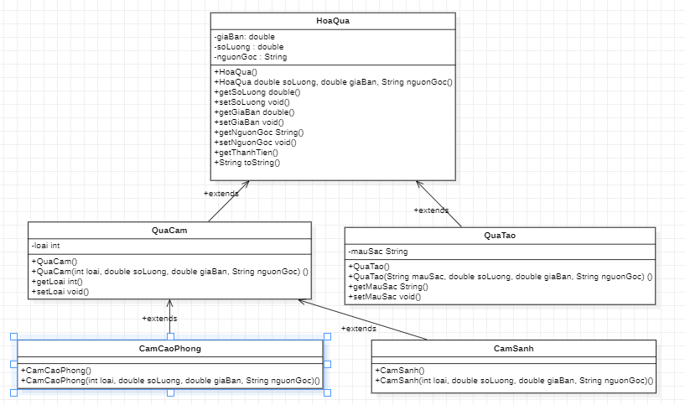

Hoa quả

package tuan5;

public class HoaQua {

private double soLuong, giaBan;

private String nguonGoc;

public HoaQua(){}

public HoaQua(double soLuong, double giaBan, String nguonGoc) {

this.soLuong = soLuong;

this.giaBan = giaBan;

this.nguonGoc = nguonGoc;

}

public double getSoLuong() {

return soLuong;

}

public void setSoLuong(double soLuong) {

this.soLuong = soLuong;

}

public double getGiaBan() {

return giaBan;

}

public void setGiaBan(double giaBan) {

this.giaBan = giaBan;

}

public String getNguonGoc() {

return nguonGoc;

}

public void setNguonGoc(String nguonGoc) {

this.nguonGoc = nguonGoc;

}

public double getThanhTien(double x) {

double tien;

tien = this.giaBan*x;

System.out.println("Tien phai tra "+ tien);

return tien;

}

@Override

public String toString() {

return "HoaQua{" + "soLuong=" + soLuong + ", giaBan=" + giaBan + ", nguonGoc=" + nguonGoc + '}';

}

}

Qủa cam

package tuan5;

public class QuaCam extends HoaQua {

private int loai;

public QuaCam(){}

public QuaCam(int loai, double soLuong, double giaBan, String nguonGoc) {

super(soLuong, giaBan, nguonGoc);

this.loai = loai;

}

public int getLoai() {

return loai;

}

public void setLoai(int loai) {

this.loai = loai;

}

}

Quả táo:

package tuan5;

public class QuaTao extends HoaQua {

private String mauSac;

public QuaTao() {}

public QuaTao(String mauSac, double soLuong, double giaBan, String nguonGoc) {

super(soLuong, giaBan, nguonGoc);

this.mauSac = mauSac;

}

public String getMauSac() {

return mauSac;

}

public void setMauSac(String mauSac) {

this.mauSac = mauSac;

}

}

Cam sành:

package tuan5;

public class CamSanh extends QuaCam {

public CamSanh() {

}

public CamSanh(int loai, double soLuong, double giaBan, String nguonGoc) {

super(loai, soLuong, giaBan, nguonGoc);

}

}

Cam cao phong:

package tuan5;

public class CamCaoPhong extends QuaCam {

public CamCaoPhong() {

}

public CamCaoPhong(int loai, double soLuong, double giaBan, String nguonGoc) {

super(loai, soLuong, giaBan, nguonGoc);

}

}

package tuan5;

import java.util.Scanner;

public class Main {

public static void main(String[] args) {

Scanner nt = new Scanner(System.in);

QuaCam qc = new QuaCam();

CamSanh cs = new CamSanh();

QuaTao qt = new QuaTao();

CamCaoPhong ccp = new CamCaoPhong();

System.out.println("Nhap so luong ");

qc.setSoLuong(nt.nextDouble());

System.out.println("Nhap gia ban");

qc.setGiaBan(nt.nextDouble());

System.out.println("Nhap Loai");

qc.setLoai(nt.nextInt());

System.out.println("Nhap so luong hang lay");

qc.getThanhTien(nt.nextDouble());

System.out.println("Nhap so luong ");

cs.setSoLuong(nt.nextDouble());

System.out.println("Nhap gia ban");

cs.setGiaBan(nt.nextDouble());

System.out.println("Nhap Loai");

cs.setLoai(nt.nextInt());

System.out.println("Nhap so luong hang lay");

cs.getThanhTien(nt.nextDouble());

System.out.println("Nhap so luong ");

qt.setSoLuong(nt.nextDouble());

System.out.println("Nhap gia ban");

qt.setGiaBan(nt.nextDouble());

System.out.println("Nhap mau");

qt.setMauSac("\nxanh");

System.out.println("Nhap so luong hang lay");

qt.getThanhTien(nt.nextDouble());

}

}

Bài 3:

Shape:

package tuan5_2;

public class Shape {

private String color = "red";

private boolean filled = true;

public Shape() {

}

public Shape(String color, boolean filled) {

this.color = color;

this.filled = filled;

}

public String getColor() {

return color;

}

public void setColor(String color) {

this.color = color;

}

public boolean isFilled() {

return filled;

}

public void setFilled(boolean filled) {

this.filled = filled;

}

@Override

public String toString() {

return "Shape{" + "color=" + color + ", filled=" + filled + '}';

}

}

Circle:

package tuan5_2;

public class Circle extends Shape {

private double radius = 1.0;

private double Pi = 3.14;

public Circle() {

}

public Circle(String color, boolean filled, double radius) {

super(color, filled);

this.radius = radius;

}

public double getRadius() {

return radius;

}

public void setRadius(double radius) {

this.radius = radius;

}

public double getArea(){

double area;

area = radius*Pi*radius;

System.out.println("Area = " + area);

return area;

}

public double getPerimeter() {

double per;

per = this.radius*2*Pi;

., System.out.println("Perimeter = "+ per);

return per;

}

@Override

public String toString() {

return "Circle{" + "radius=" + radius + '}';

}

}

Rectangle:

package tuan5_2;

public class Rectangle extends Shape {

private double width = 1.0;

private double length = 1.0;

public Rectangle() {

}

public Rectangle(String color, boolean filled) {

super(color, filled);

}

public Rectangle(String color, boolean filled, double width, double length) {

super(color, filled);

this.length = length;

this.width = width;

}

public double getWidth() {

return width;

}

public void setWidth(double width) {

this.width = width;

}

public double getLength() {

return length;

}

public void setLength(double length) {

this.length = length;

}

public double getArea(){

double areaa;

areaa = this.length*this.width;

return areaa;

}

public double getPerimeter(){

double perr;

perr = (this.length+this.width)*2;

return perr;

}

@Override

public String toString() {

return "Rectangle{" + "width=" + width + ", length=" + length + '}';

}

}

Square:

package tuan5_2;

public class Square extends Rectangle {

private double side = 1.0;

public Square() {

}

public Square(double side) {

this.side = side;

}

public Square(String color, boolean filled, double side) {

super(color, filled);

this.side = side;

}

public double getSide() {

return side;

}

public void setSide(double side) {

this.side = side;

}

public void setWight(double side) {

this.side = side;

super.setWidth(side);

}

public void setLeght(double side) {

this.side = side;

super.setLength(side);

}

}

package tuan5_2;

import java.util.Scanner;

public class Main {

public static void main(String[] args) {

Scanner input = new Scanner(System.in);

Circle cl = new Circle();

System.out.println("Nhap radius");

cl.setRadius(input.nextDouble());

cl.getArea();

cl.getPerimeter();

Rectangle recle = new Rectangle();

System.out.println("Nhap leight");

recle.setLength(input.nextDouble());

System.out.println("Nhap wight");

recle.setWidth(input.nextDouble());

}

}